I. Listening

General Tips
- Consentrate! Keep focus!
- Read the questions first if you have time.
- Answers can come quickly and don’t come at regular intervals so keep your eye on the next question. In addition, don’t try to write the whole word if it is too complicated. For example, you can write ‘uni’ for ‘universe’ and ‘bksp’ for ‘bookshop’.
- Make notes(such as likely answers that you guess) when you are not sure whether your answers are correct or not because you can only hear the recording once. Don’t leave any blank.
- There could be a big gap between two answers so don’t be panic when you are not hearing the answers of the question. And answers may come altogether in a short period of time so don’t write when you only hear one answer.
- Common traps:
Answers are changed;
Using similar words rather than paraphrases.
- Pay attention to plurals.
- You should listen the introduction carefully. Don’t skip it. It will tell you who will be talking and what they will talk about.
- Repeat listening and try to completely understand every sentence in the audio. Don’t listen to the audio one by one quickly.
- Note that the adjectives before numbers, don’t’ forget to write it down. For example, in “approximately 2000”, it is wrong only to write “2000”.
- The words you fill in the blanks must be grammatically correct when joining the sentence.
For example,
hospital
PLACE: hospital
The place to meet is at the hostipal. Therefore ‘the hostipal’ and ‘hostipal’ are not correct answers.
- Don’t try to understand everything. Just focus on the answers you are looking for.
- There will be gaps between answers. Don’t be panic when you can not find answers and just keep on listening. If you miss an answer, move quickly to the next one.
- Using similar words rather than paraphrases. You should not expect to hear exactly the words in the questions as same as in the recordings.
- Technical or academic language is not always paraphrased.
- Tips of English names.
- Capital letters: Simon Brambling
- Spelling.
- Common Names: Simon, John Smith
- Initials: J.K. Rowling
- Titles: Mr. Mrs. Miss. Ms. Sir. Lady
- Predicting answers.
For instance,
He would like to meet at/in/on/none __________.
If different prepositioins are followed, we can predict the answers according to them.
Prepostion | Prediction | Examples
at | time | 7 o’clock
at | part of the day | noon
at | part of the week | the weekend
at | a place | the station
in | period of time | 2 days/2 hours
in | month | February
in | year | 2014
in | season | summer
on | day | Monday
on | date | 3rd May / May 3rd
none |  | now  at once  tomorrow  next year  this afternoon
none | a person | Marry

- The questions come in order but the answer options will not come in order in the recording, for example you will hear somehting about option B first before you hear option A.
- You must develop speed reading skills to be able to read all answers and spots key words before recording starts. This skill comes with practice.
- It’s necessary always to read transcripts and listening again. After that, check the answer key. N.B. check the answers after reading transcript and listening again.
- Write what you hear and don’t try to reformulate the words in the answer.
Example:
Children must be accompied by an adult at all time.
Question:
26. No children are allowed without _______.
Answer:
an accompanying adult (×)
an adult () This is the words you probably hear from the recording so you don’t need to add any word like ‘accompanying’ to the answer.

Multiple Choice Tips
- Look for the title.
- Read the question.
- Paraphrase.
- Read all the options. (You will hear all the options in the recording, but you should choose the correct ones.)
- Watch out for answers that are correct but then the speaker takes them away.
- Other tips:
Both question words and answer options will be paraphrased.
Answers do not follow the order of the options.

Listening for plurals
- First of all, you must know which words are uncountable nouns and which are countable.
- Note that native English speakers always contract words when they were speaking. For instance, “Charity work is so important that…” is articulated as “Charity work’s” with an apostrophe in it but work is uncountable here. So don’t write “Charity works” which is a wrong answer.
- Use grammar to help you. For example, in “… money donations or ____” the answer should be a plural. But in compound words such as “a grass roots project” “grass roots” is plural because it has not any sigular form.

II. Speaking
- The Importance of Part 1.
Part 1 is equivalent to Part 2 and Part 3; you can use less common words or collocations in this part. When your Part 3 is weak, the examiner will take part 1 more into account.
- Lexical chunks.
A sentence is made of several lexical chunks.
A lexical chunk is a group of words that go well together.
The important thing is to learn word in chunks in context.
- Don’t repeat the words in the questios.
For instance, the examiner asks you how long you live there. You’d better not say that I have lived here for 5 years. Instead, you could say, “I arrived here in 2020. I’ve been living here for 5 years.” After that, you can extend your answer by adding that how time flies when you are busy and productive.
- Greeting examiners.
  - Don’t address examiners first name preceded by Miss/Mr.. That’s not correct in English.
- Suggestions
- Open your mouth and speak slowly. Focus on grammatical range and accuracy.
- Don’t ask the examiner questions in the speaking part 1. Don’t give extended answers when the examiner only ask about your ID, your name. For example:
Could you show me your ID?
Sure, here it is. (That’s enough.)
What’s your name, please?
My name’s Xiao Ming. (Use the extracted “name’s” instead of “name is” to show that your speaking is in a high level).
Where do you come from?
I come from Handan ( which is in the north of China). (Don’t talk about how beautiful you hometown is or something else.)
- Don’t pause and don’t repeat yourself. Use synonyms of the words you said.
- Don’t answer the questions with only one word. If you did it, how could the examiner know your English speaking.
- You should try to use some idioms or slang when you are answering questions so that the examiner can know that you have a wide range of vocabulary and don’t quote words from books because they are not appropriate for speaking.
- Using phrasal verbs to impress the IELTS examiner.
- Recording your speaking English and listening it. Pay attention to the errors and correct them when you speak next time. That may help you improve your speaking English.
- Make eye contact with the examiner to show repect and confident. That is necessary in western countries when talking to people.
- How to improve your pronunciation?
- Speak slowly. Speaking too quickly negatively impact pronunciation.
- Focus on enunciation.
- Listen and mimic. Listen to BBC and repeat(Download transcripts).
- Practice connected speech. Don’t jump to connected speech. You should enunciate every word and then you will connect these words naturally.
- Intonation is crucial in part 3 of speaking section. It can improve you score.
In speaking section, question 2 and 3 are always linked to each other.

For part 3, you should have 3 things in your answer:
• Give your opinion
• Give an example of your opinion
• Give a concluding sentence
When you prepare for the test, you should write out your answers ahead of time. Later, when you get comfortable with that you can stop writing them out and get better at responding quickly.
Remember, planning ahead and preparing is the key to getting more confidence.
Final tip-check out the NY Times and look at the newspaper sections- those are typical IELTS Speaking topics.

- Stay tune to the latest news(NY Times, BBC). Some topics may appear in the IELTS exam.
- Correcting pronunciation. Listen, mimic, record your speaking English and review it.
- It is not necessary to speak British English, accent is accepted when you pronounce correctly and express yourself clearly.
- Incooperate chunking into your speaking English. Chunking is how we group our words together.
- Use elision such as “I’m, don’t, couldn’t” and so forth.
- Focus on one topic one time and delve into it, then the next. Don’t practise various topics at the same time. Use specific words instead of general ones.
- How to develop your speaking at home for free?
Speaking Task 1
- List the common topics for speaking task 1 and try to answer them.
- It is vital to record your speaking and check it later. Don’t write your answers but record them because you think more about grammar,.. and you probably make less mistakes.
- Don’t speak with hesitations such as “er…” or “emmm”.
- Try to use wide range of vocabulary such as using “boiling, scorching, sweltering” instead of “hot”.
- Use NoteLLM and ChatGPT to learn vocabulary of various topics of speaking IELTS English Test. (from a user’s post in Twitter)
- Never use basic terms such as “nice”, “be” when you are in a speaking test. For example,
* “It’s a nice building” could be replaced by
“The building has beautiful artichitecture”,
* “We have nice friends” should be replaced by
“We have friends who are always there for us.”
“I love mathematics because it is a nice school subject” is replaced by
“My most favourite school subject is geography.”
- “I was in an interview yesterday.”
“I participated an interview yesterday.”

III. Reading
- Read the questions first.
- In true or false questions answers come in order in the passage. (Important)
- Pay attention to the next question. If the Question 2 were not given, don’t read through all the passage and stop at the sentence matches Question 3. Because NO.2 is between NO.1 and NO.3. So
- “True” means that the anwer share the same points as the statement in the passage. “False” means opposite/controdict so it neither close nor near but far from it. As in the following example, “about” means a little bit more or less, so it is true.
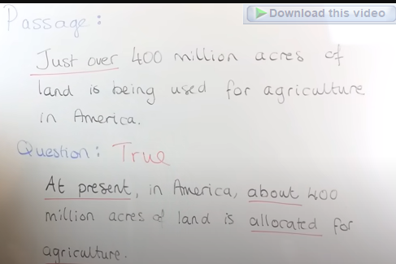

IV. Writing

General Notes
- Don’t use repeat words. Look for repeated words and circle them.
Use synonyms as more as possible.
For example, university = tertiary education / college
- Use linking words and transitional words. Do you use linking words between every sentence? Examiners look for the linking words. Don’t forget them. Linking words are not linked adverbs but are meaningful ones. a->b, b->c… Cohesion and coherence are critically important.
- Suggestions from all ear English
- Do your ideas make sense?
- Grammar: Write sentences with various structures. Write complex sentences as many as you can.
- Mistakes: Make a list of common errors. Look at verb tenses, circle the different sentences. Make sure that you use them correctly.
- If you made mistakes on complex grammar, that’s OK, but if made mistakes about pass simple, you can’t achieve a high score.
- You should know what is a table, a graph or anything else.
- You should spend 4 or 5 minutes planning before writing and spend the same time checking after writing. You practice that again and again every time you write essays, it will be natural when you are writing something.
- Review model answers and examiner’s comments on that, you will know how to get a high score in writing tasks.
- Task 1 top tip – remember it’s always ‘the number of’ for countable nouns and ‘the amount of’ for uncountable.
For example: The number of people increased. The amount of rice increased.
- Try answering the question without consulting any dictionary.
- Write solid examples to support the point in each paragraph.
- In writing task 2, incorporating conditionals and hypothetical proposition can help you get a high score. Don’t use them in writing task 1.
- You’d better not use words in the question but you can use their synonyms instead.
- It’s a big mistake to only write one sentence in the overview paragraph.
- In academic English essays we avoid using pronouns. We don’t say “I will research” but say “This essay is a research of …”.
- Difference between band 6.5 and 8 essays in IETLS writing.
If you write “There are more and more students…”, you get 6.5. Whereas, If you write a sophisticated sentence like “There is an increasing number of students…”, you probably get 8.
Write “attend university” instead of “go to university”.
- Use specific words instead of general words. For instance, write “we will meet international students, foreigners in the university” rather than “We will meet a lot of people…”.
- Use formal and academic words because it is an academica English test.
- Review some model answers with examiners’ comment, that gives you insight of IELTS and can help you to improve your writing.
- Don’t read example answers immidiately after reading the introdution. Try to write your own draft before read them or you won’t make any progress on your writing skill.
- Don’t state your point explictly.
For instance,“Climate change is dangerous, and regulation is needed.” is too direct and simple. Instead, we should write sentence like “Given the alarming rate of climate change, one might sumarise that strict pollution controls are needed.”
Furthermore, writing sentences implicitly can help you gain high-level English ability which benefits your English reading and listening. Because once you gain the ability, you are easily able to understand and paraphrase complicated sentences with the same writing style in reading and listening tasks.
- Use inversion in your essays in order give sentences more emphasis. Then you can gain a higher band score subsequently.
Examples:
Not only do students gain academic knowledge, but they also develop personal skills.

Writing Task 1
- First of all, you should analyse the task.
- Then try to make a plan organise your thought before start writing, this is critically important.
- Paraphrase the description in the first paragraph.
- Write at least 150 words, normally most reports are between 170 and 190 words.
- To prepare for task 1 in writing section, you can read the business section in a newspaper to learn how to describe increasing and decreasing.
- For writing task 1, don’t try to describe every category in detail; fous on the most significant ones.
- Overview paragraph is the most important part of Writing Task 1. A limited overview will limit your score. Don’t forget to write an overview and a report without an overview can only get band 5.
- Incorporate numbers in body paragraphs to support your theses if there are in bar charts, or some other tasks.
- The length of introduction paragraphs is not uniform; it depends on the information in the description in the Task 1.
- When writing an introduction paragraph, it is not necessary to read the main part of the question. Only the sentences of description should be paraphrased.
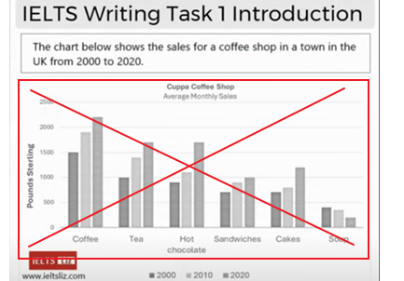

- Line Charts
How to master line charts for Task 1?

Reliable Resources:
BBC Bitesize – Graphs and Charts
UK Government Research on Productivity Statistics
WikiHow – How to Interpret a Graph
- Bar Charts
News with bar charts

- Maps
How to describe a map for academic task 1?
- If both maps have an area that is unchanged between the time dates, this can be written as:
Over fifty years period both maps have maintained a distinct recreational area despite the extensive construction in the surrounding areas.
- “north-east” and its relative words are nouns, adjectives, and adverbs.
- The map shows/demonstrates/illutrates…

Writing Task 2
- IELTS Essay Structure.
All IELTS essays will have the structure as below.
An introduction.
Body Paragraph 1
Body Paragraph 2
Body Paragraph 3 (Optional)
Conclusion

- An introduction.
How to write an introduction in Writing Task 2?
- Normally, there are three parts of an introduction paragraph:
(1) The hook (NOT needed)
(2) Background statement
(3) Thesis statement
- The hook is not needed. One reason is that the IELTS examiners don’t look for something interesting so your essay don’t have to be interested. Second is you don’t have enough time.
- Whereas, the other two parts are important and essential.
- Background statement is paraphrase of the question, but don’t copy it. Instead, use your different words to say the same thing.
- Thesis statement is your opinion. It is a response to the question.
- The number of an introduction paragraph is between 35 to 50 words.
- Body paragraphs

- Do ideas should be insteresting in Writing Task 2?
No, they don’t. It is not important whether your idea is insteresting or not.
The exaiminer is looking for task response. To response the task you should have focused ideas in each paragraph. Then you should have supported ideas and should develop and extend these ideas with more details.
- Normally, the essay in Writing Task 2 is between 270 and 290 words. You will NOT get a higher score for a longer essay. In fact, a longer essay can attract critism and can gain a lower score.
- If you only have 5 minutes left, write an conclusion immediately. Because a conclusion account for 25% of an essay in Task 2.
- You will lose marks if you write irrelevant information of go off topic.
- “As far as I am concerned” is not appropriate for written English; it is colloquial. Formal expression can be used in Task 2 are “In my opinion”, “I think/believe” and “In my view.” which will help the examiner to spot your thesis statement easily.
- “like” is an informal word when it is used as a linking device. We should use “such as” or “namely” instead. To illustrate, “Fast food can lead to serious helthy problems, like obesity and cardian disease, when eaten in quantity.”
Other link devices such as “For example, For instance, To illustrate, As an illustration and To give a clear example” can also be used; they are all formal ones.
- Never use “but” or “because” at the start of a sentence in formal IELTS writing.
- “Although” and “Though” are followed by a sentence. Apparently, “Though the rise in urban...” is not correct.

V. General
1. Do some authentic examination papers but not only do them but also keep on reading, writing, listening and speaking English.
2. You should use a mix of sentences structures in speaking and writing English if you want to get a score of 7 or more. Namely, you need simple and compound sentences. Be sure not to make a lot of mistakes, a few mistakes are allowed up to a band score of 8. Don’t try using rare grammar tenses like past perfect.
3. Aiming at band 8 or above then you may get band 7.5. It is said that if you aim at stars you might reach the moon. Because you don’t have to take IELTS for many times so that you can save money.
4. Take at least one full test at home before sitting a real IELTS test. You had better set a alarm and finish all the three tests except for speaking within 2 hours and 40 minutes.
5. Make use of thesauruses to find synonyms.

Vocabulary
- When paraphrasing, there is no need to replace all words in the question. The examiners are looking for whether you understand and can paraphrase or not.
- Use synonyms appropriately. Some of synonyms of a word can be used but somes are not due the different meanings of the sentences in which they are.
For instance, ‘consume’ and ‘use’ are synonyms but they are not always equivalent to each other at all context.

Examples of ‘consume’ and ‘use’.
- The amount of fuel consumed…
The amount of fuel used… ()
- The amount of meat consumed…
The amount of meat used… (×) (Meat couldn’t be used.)
The amount of meat eaten… () (It only could be eaten.)

Examples of “human” and “people”
- “Human” is used when you want to disginguish between human beings and animal and machines while “people” means persons, men, women and children.
Human activities, sucha deforestation and fossil fuel consumption, have led to serious environmental problems.
Due to traffic congestion, humans should make an effort to use public transportation in urban areas. (×) (‘humans’ is not appropriately used in this sentence. We should use ‘people’ instead.)

Examples of ‘youth’, ‘teenager’ and ‘adolescent’.
- The growth in teenage crime…
The growth in adolescent crime… ()
The growth in youth crime… (×)
The number of youths committing crime has grown. ()

VI. Topics

Speaking or writing topics.
- Living in Cities
Complex sentences.
People choose to live in cities because they appreciate the accessibility of amenities, the cultural diversity and the range of employment opportunities available.

Cities offer a plethora of experiences, from a vibrant nightlife and a diverse range of cuisines, but they also pose challenges like noisy pollution and overcrowding, which can significantly impact the quality of life.

Even though the city life, with its convenience and diversity, holds it’s a great appeal for many, the longing for a slower pace of life and a close-knit community is leading some to reconsider and move to countryside.
Note: (“even though” is the symbol of transition so that it can’t be followed by only one sentence.)

Cities are becoming smarter with the integration of advanced technology into public services and infrastructure, which is improve the quality of life, even as they contend with issues like data privacy and cybersecurity.

VII. Others Notes

- Some sentences structure.
- The numbers increased dramatically in 2008.

- Tips on four sections of IELTS.
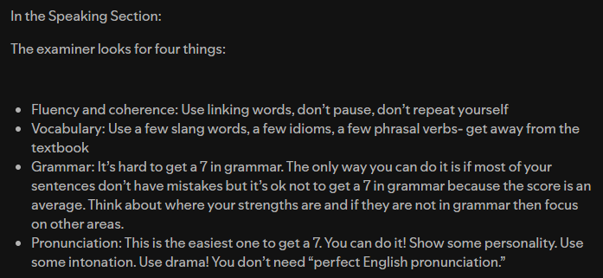
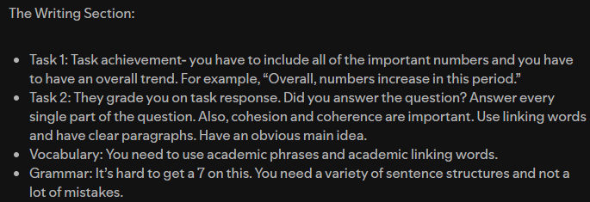

- Preparing for writing task 1 could also help you on writing task 2, so don’t think the former is not as important as the later.
- Read the official Band desriptors from IELTS.

